6. Validation Rules - 01 March 2022

Definition: Validation Rule is used to Prevent the record to store into the database, if its rule gets satisfied.



User Story 1] Prevent Applicant, if Age < 18.

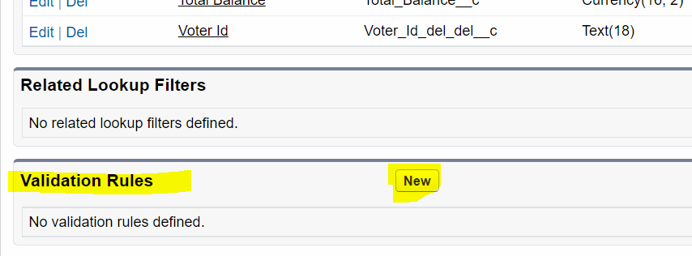

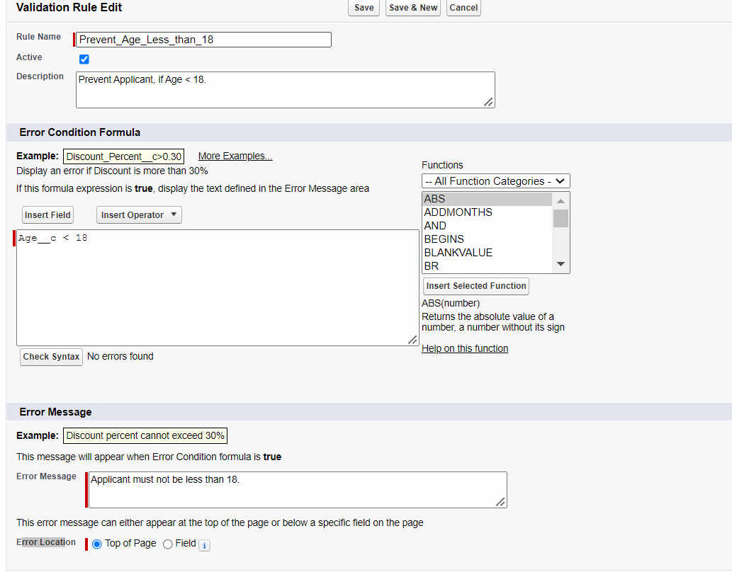

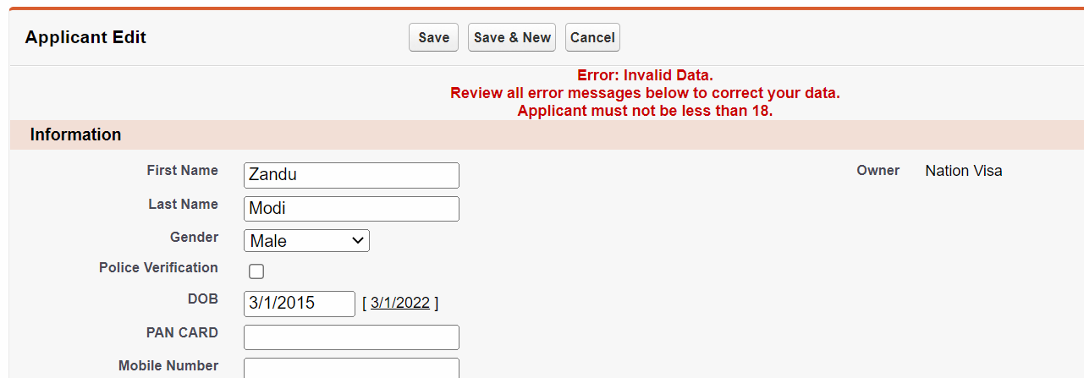

User Story 2] Prevent Applicant, if DOB Month is “August”.

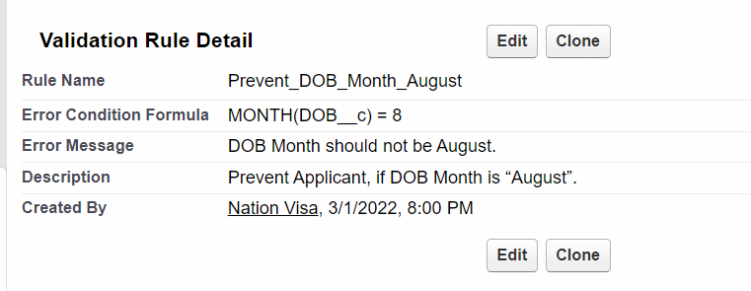

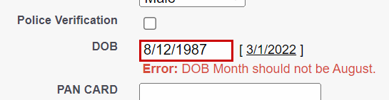

Software Developer 🡪 UNIT Testing

Software Tester (QA = Quality Assurance) 🡪 Manual Tester, Automation

User Story 3] Prevent Male Applicant.

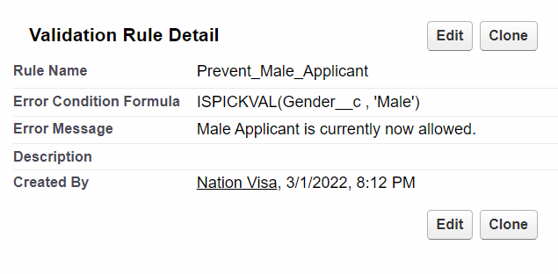

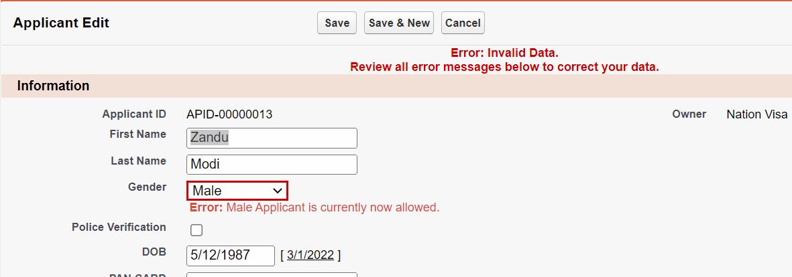

4] Prevent Applicant, if Last Name is Blank.

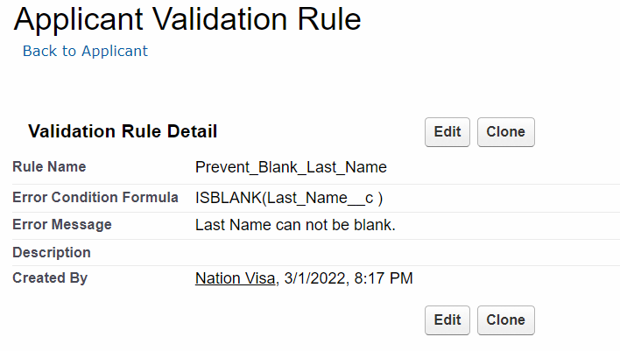

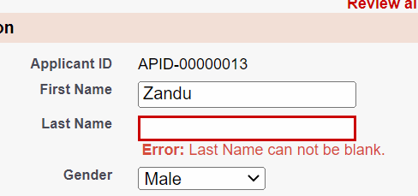

Mandatory / Required / Compulsory a Field :

1] Metadata Level (Database Level)

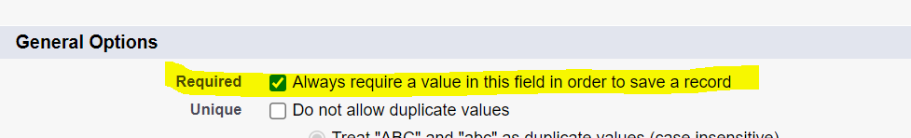

2] Validation Rule (Prevent)

User Story 5] Last Name must be mandatory for Agent (Profile).



Metadata Level REQUIRED



Validation Rule

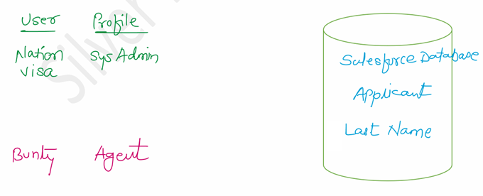

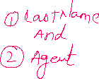

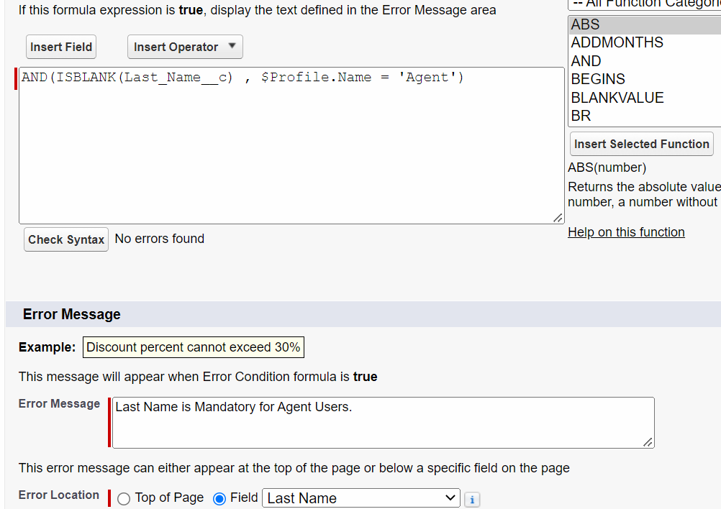

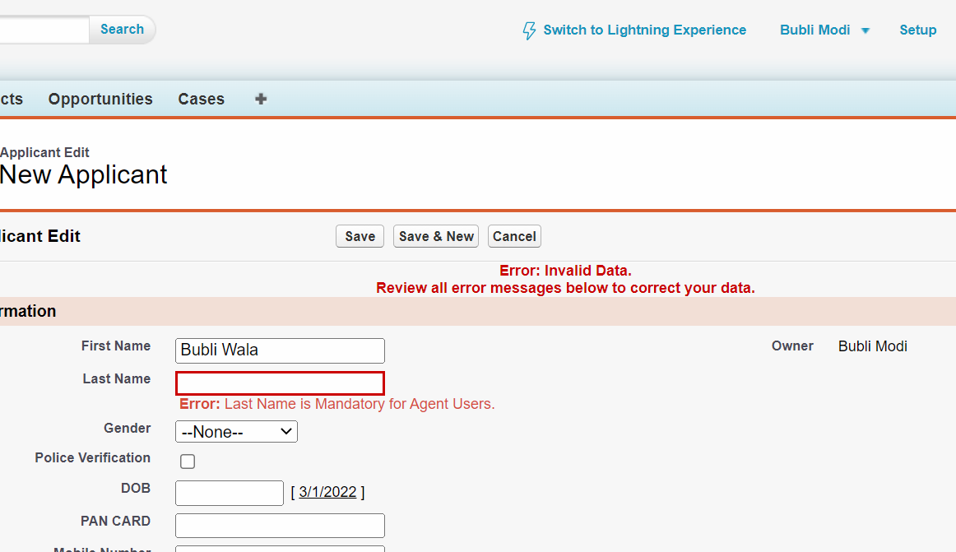

User Story 6] Prevent Applicant, if

- Gender is Female Or Transgender

- Police Verification is true.

(1 OR 2) AND 3

Actually

AND ( OR (1, 2) , 3)

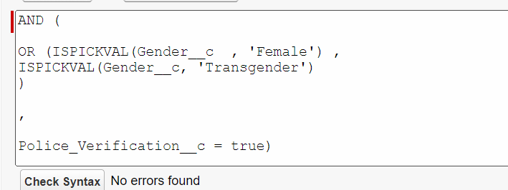

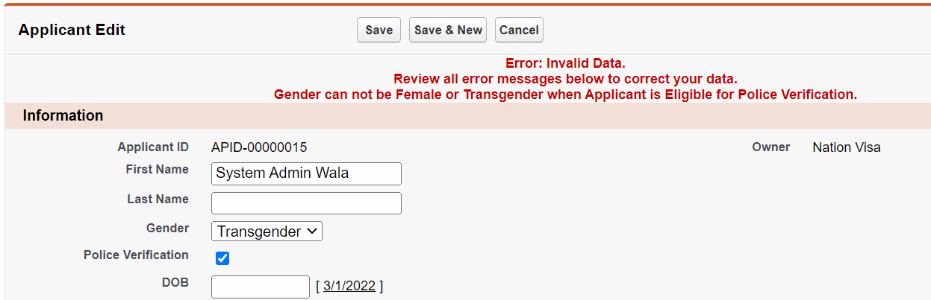

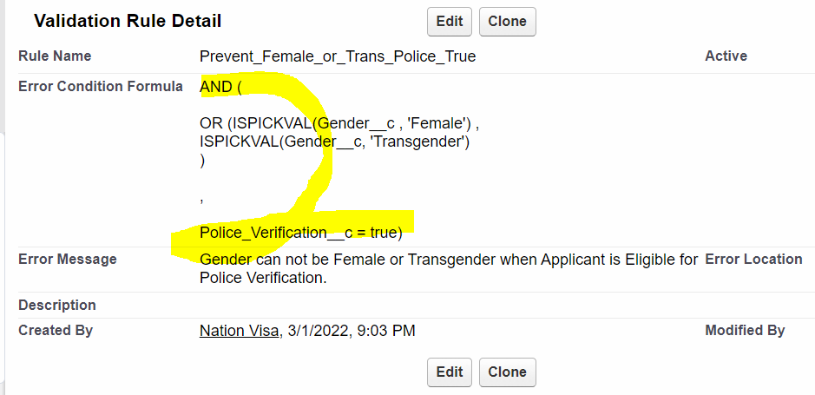

AND (  
  
OR (ISPICKVAL(Gender__c , 'Female') ,  
ISPICKVAL(Gender__c, 'Transgender')  
)  
  
,  
  
Police_Verification__c = true)

Validation Rule for Standard Object:

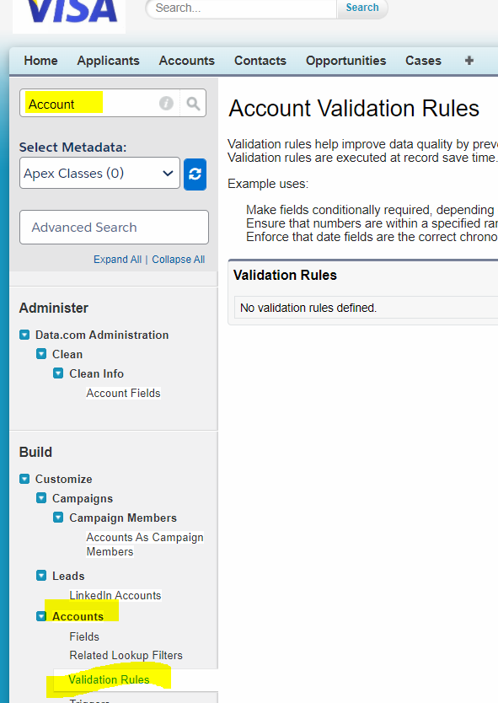

7] Prevent Applicant If,

- Age is in between 20-30 (Age>= 20 AND Age <=30)

- Gender is “Female”

- Month of DOB is November.

1 AND 2 AND 3 AND 4

AND(1,2,3,4)

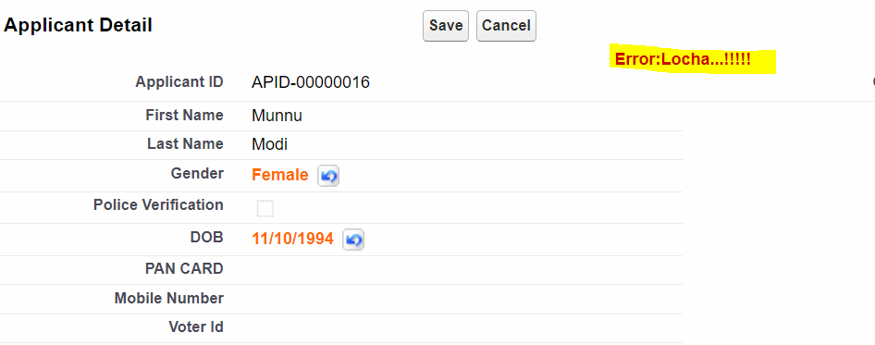

Assignments:

1] Prevent Account Record, If

- Rating is “Hot” or “Warm”.

2] Prevent Account , if

- Type is “Prospect” Or “Customer - Direct”

- Rating is “Hot”

- SLA is “Gold”.

1 OR 2 AND 3 AND 4 🡪 AND ( OR(1,2) , 3, 4)

AND (

OR( ISPICKVAL( Type , 'Prospect') ,

ISPICKVAL(Type, 'Customer - Direct')

)

,

ISPICKVAL( Rating , 'Hot') ,

ISPICKVAL( SLA__c , 'Gold')

)

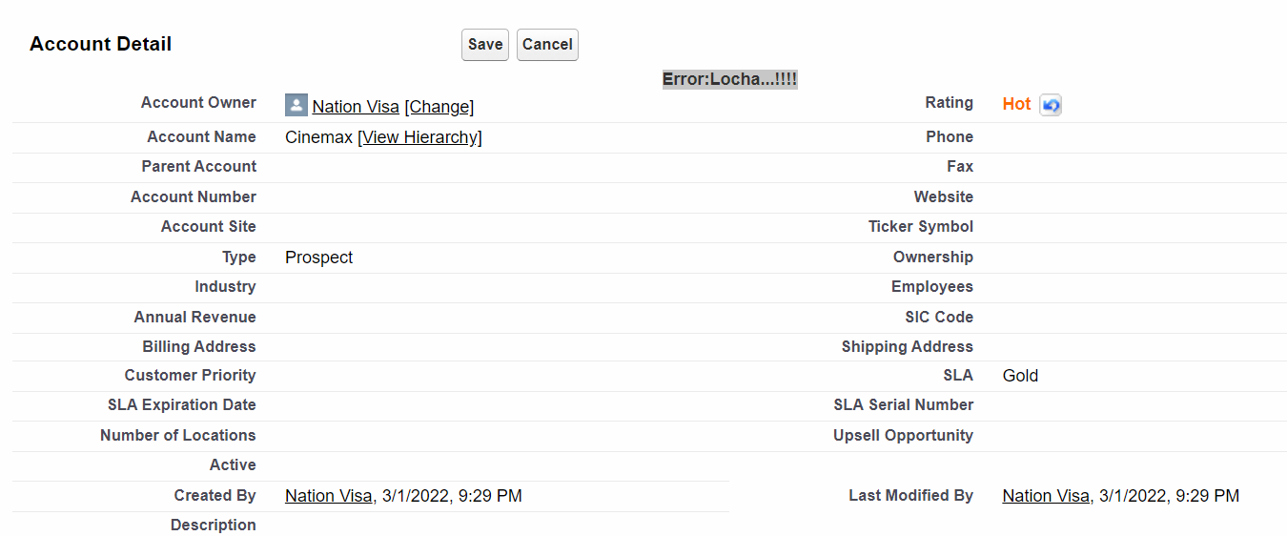

3] Prevent Opportunity, if

- Amount is in between 3000 – 10000

- Close Date Year – 2001

- Lead Source is “Web” or Phone Inquiry.

4] Prevent Case Priority High only if, the User is of “Agent” Profile.

5] Case Record Subject can not be blank for “Managers”.